**User instructions for squash**

**Quick start guide**

This section will get you going with the basics of coding a game of squash.

The following basics would be explained,

* 1. Starting the program,
  2. Introduction to coding buttons
  3. How to code
  4. Editing videos and playing
  5. Looking at game stats.

**Step 1, STARTING the program**

* When you start the program, the user interface looks as shown.

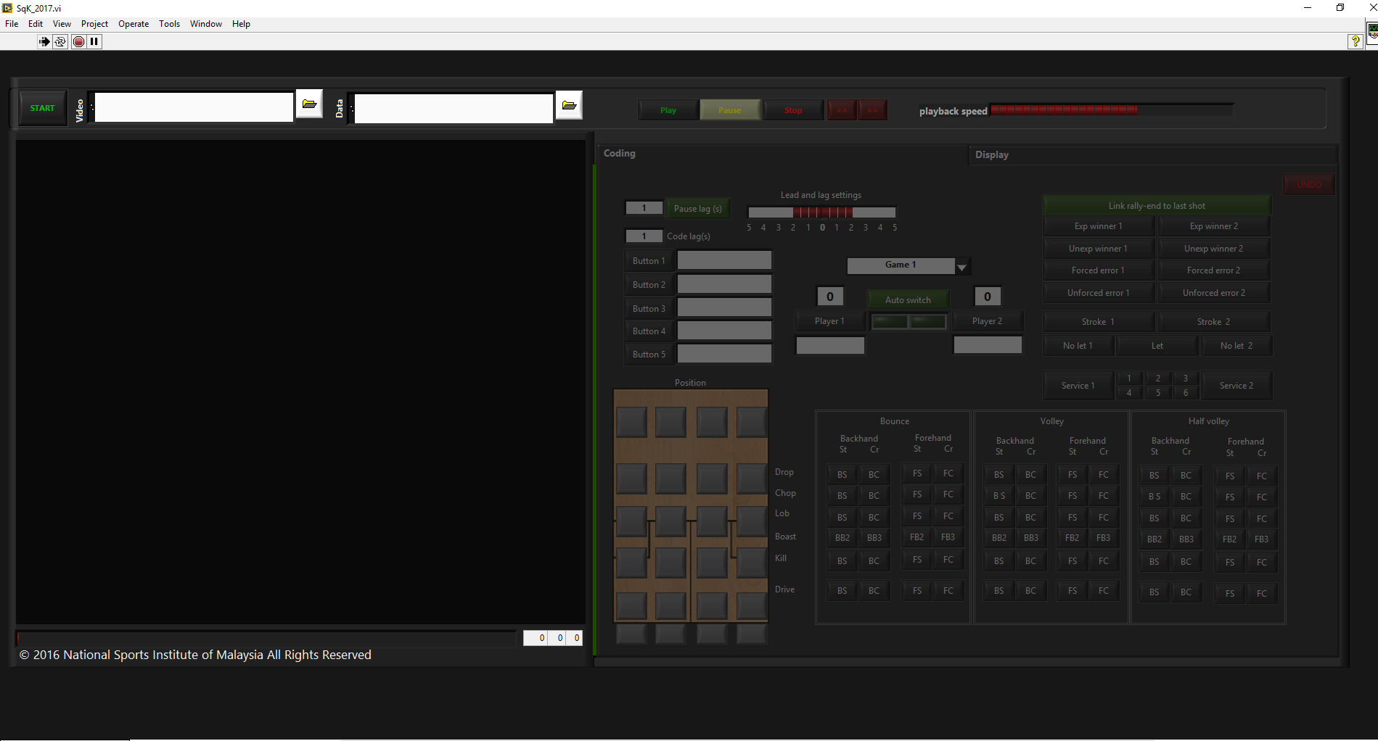

* Make sure the “run” arrow (shown in the red circle) appears black. This means the program is running.
* Please select a video file and enter the name of a “data” file in the file selector boxes (shown in blue rectangle). This tells the software which video file you intend to use and a place to save your coded data.
* Click “START”.
* If the data file is a new file that does not already exist on your computer, the software would create a new file and a pop up would ask you permission to begin a new “project”. Click yes.
* The START button would indicate RUNNING and the grayed out buttons on the right of the screen would now be active.

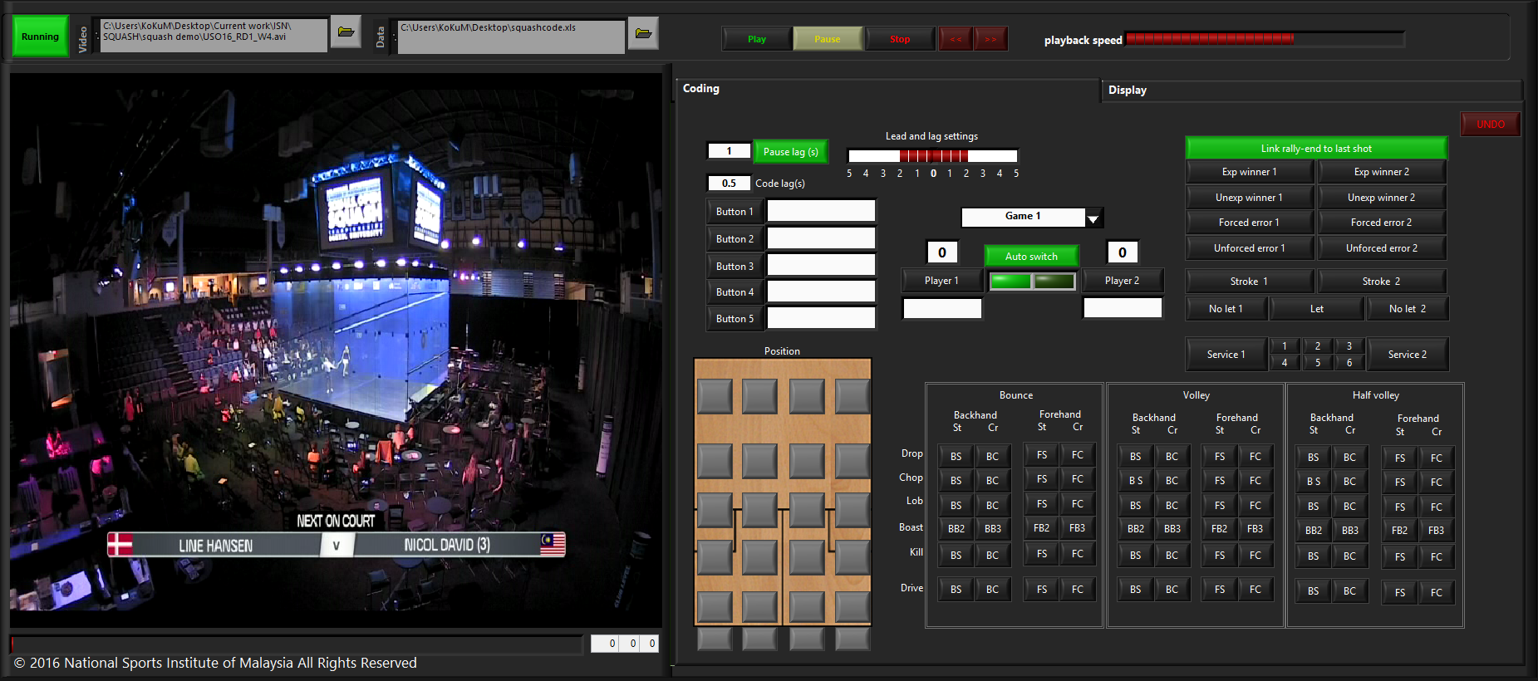

**Step 2, Introduction to coding buttons**

Now you are ready to code. Look at the buttons on the right side of the interface and familiarize yourself with them. Don’t worry if you are unsure of all of the buttons, you will become familiar as you code.

* Play controls are at the top: - play, pause, stop, fast forward, rewind, and play back speed control.



* The main coding buttons are at the bottom: - location on court and the types of shot.

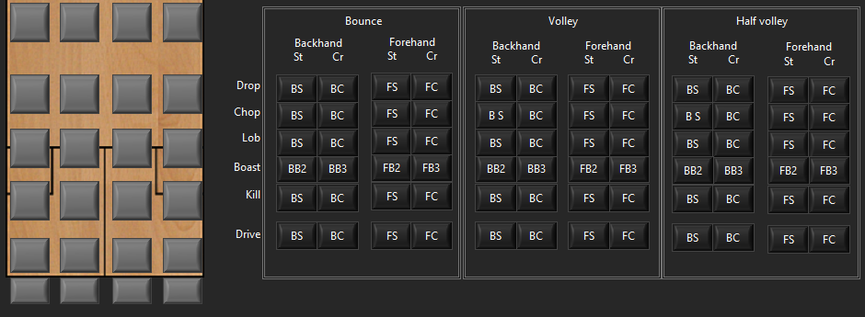

* The middle has several groups: -

Ignore the left most group. We will get to these in the advanced section.

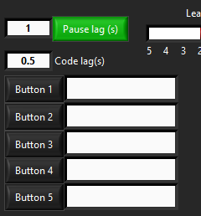

The middle group selects which game you are coding, player names, and keeps score.

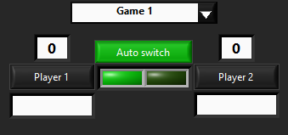

The group on the right codes the beginning and end of rallies.

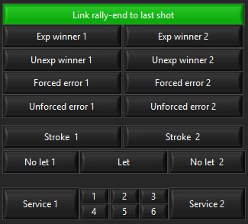

There is also an undo button on the top right corner.



**Step 3, How to code**

Before coding, play the video and get used to controlling the video. You can stop and pause by clicking those buttons. To fast forward or rewind, hold those buttons down. Keyboard shortcuts for pause is the space bar. Fast forward and rewind are the left and right arrow keys.

You can also use the progress bar below the video to drag it to any time you like.

Note that when you click pause, the video plays for exactly 1 second after you pause. When you un-pause, the video “goes back” and plays from the point at which you pressed pause. The reason for this is explained later. But it is good to notice this effect at this point.

**Let’s code!!!**

First, enter player names, and select which game you are coding.



To code an event, you need to press pause. The event is coded to the point (time) at which the video was paused.

So hit pause when the player is hitting the shot on the video. The video will play for exactly 1 second, allowing you to see what shot is being played. Now you can code using the correct buttons. And un- pause.

OK let’s try coding one rally.

Select game 1 (if you are coding game 1), and play the video. When the player serves, hit pause, and select service (1 or 2 depending on the player). Then un-pause.

When the next player hits a reply shot, hit pause, and select the location on the court he hits the shot from and the type of shot. Then un-pause.

Repeat until the last shot of the rally.

Note that you DO NOT need to code how the rally ended together with the last shot. The end of the rally can be coded at any time after the shot was coded. For example let’s say you coded a backhand straight drive. And hit un-pause. As the video continues to play, you realize that the drive was a winning shot by player 1. You can simply hit expected winner 1, and this code would be automatically linked with the previous code (backhand straight drive).

You also do not need to code which player is hitting the shot, provided you select the correct player serving. The software will automatically keep track and alternate the player code.

**Step 4, Editing videos and playing**

Once you are done with coding, click the “display” tab (blue rectangle)

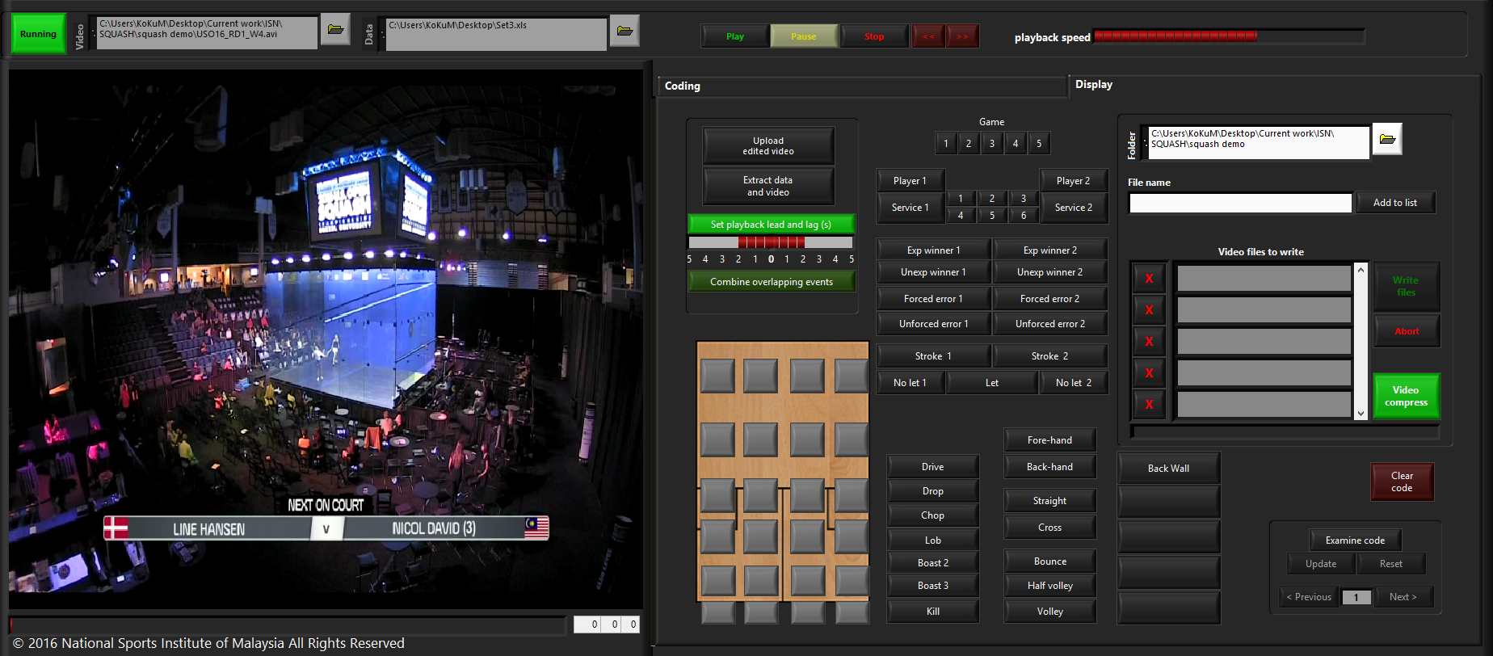

Ignore all the buttons on the right half of this tab (in the red rectangle) and focus on the other buttons.

Select any combination of these buttons and click “extract data and video” (yellow rectangle). For example, you can try backhand straight drives. This will extract data on these shots and extract video clips of all backhand straight drives.

Click “upload edited video” (yellow rectangle) to play the edited video clips. The red bars will adjust the time before and after the event to play video.

Note: - this time must be set before you select “extract data and video”. If you modify this time, click “extract data and video” again.

**Step 5, Looking at game stats.**

If you wish to see the stats on the entire match or the filtered stats from the events you selected, press the keyboard shortcut “d”. The screen below pops up. On the left is player 1 and on the right is player 2.

You can select the entire match of filtered events using the control above player 1 locations (red rectangle). Alternatively just hit the keyboard shortcut “f”.

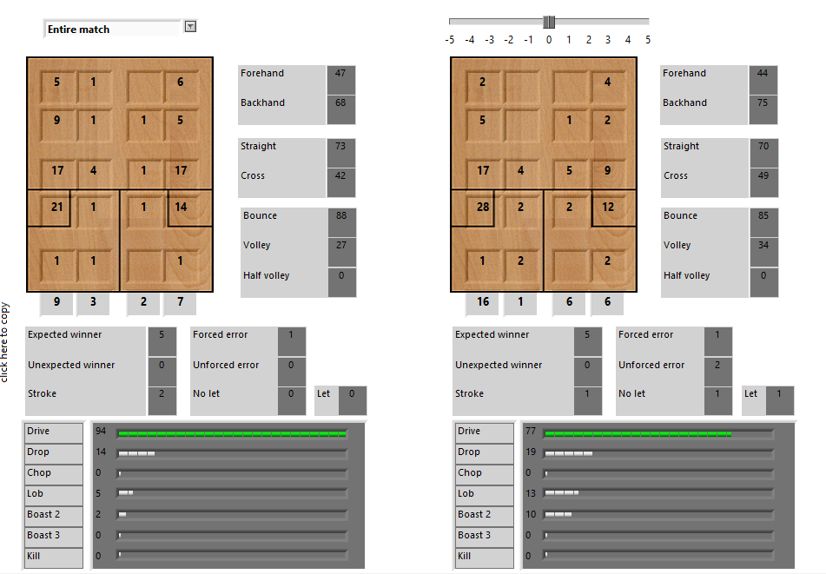

The image below shows the filtered information from backhand straight drops.   
